**TRAINING REPORT**

**On**

**Banking system**

Submitted to RAYAT-BAHRA UNIVERSITY in partial fulfillment of the requirement for the award of the degree of

**B.C.A(USET)**

**(2018-2021)**



**Submitted By**

**ADITYA ALOK**

**ROLL NO. 1803002003**

**DEPARTMENT OF COMPUTER APPLICATIONS**

*RAYAT BAHRA UNIVERSITY, MOHALI*

*USET*

**JULY 2020**

**TRAINING REPORT**

**On**

**BANKING SYSTEM**

Submitted to RAYAT BAHRA UNIVERSITY in partial fulfillment of the requirement for the award of the degree of

**ADITYA ALOK**

**ROLL NO. 1803002003**

**B.C.A**

**in**

**COMPUTER APPLICATIONS**

*RAYAT BAHRA UNIVERSITY, MOHALI*

*USET*

**JULY 2020**

**DEPARTMENT OF COMPUTER APPLICATIONS**

**PREFACE**

Training is an integral part of B.C.A. and each and every student has to undergo the training for 6 weeks in a company.

This record is concerned about my practical training after the 4th semester of our B.C.A. I have taken my Practical training in **Solitaire Infosys Mohali.** During this training, i got to learn many new things about the industry and the current requirements of companies. This training proved to be a milestone in my knowledge of present industry. Every say and every moment was an experience in itself, an experience which theoretical study can’t provide.

**ACKNOWLEDGEMENT**

It is my pleasure to be indebted to various people, who directly or indirectly contributed in the development of this work and who influenced my thinking, behavior and acts during the course of study.

I express my sincere gratitude to ***MISS ANITA GOYAL*** worthy HOD for providing me an opportunity to undergo summer training at ***Solitaire Infosys Mohali.***

I am thankful to my project guide ***Miss SAKSHI MOHANIA*** for her support, cooperation, and motivation provided to us during the training for constant inspiration, presence and blessings.

Lastly, I0 would like to thank the almighty and my parents for their moral support and my friends with whom I shared my day-to day experience and received lots of suggestions that my quality of work.

**DECLARATION**

Sourav Sharma Roll No. 1803002045, B.C.A(Semester-V) of the **USETRayat Bahra UniversityMohali** hereby declare that the Training Report entitled **“Banking system”**is an original work and data provided in the study is authentic to the best of my knowledge.This report has not been submitted to any other Institute for the award of any other degree.

**……………………………………………………………………………..**

**INDEX**

|  |  |  |  |
| --- | --- | --- | --- |
| **Sr no.** | | **Topics** | **Page no.** |
| **1** | | **Introduction** | **7-10** |
| **2** | | **System Analysis** | **11-20** |
| **3** | | **Literature Survey** | **21-29** |
| **4** | | **Requirements and Specifications** | **30** |
| **5** | | **System Design** | **31-36** |
| **6** | | **Snapshots of project** | **37-46** |
| **7** | | **Implementations** | **47** |
| **8** | **Conclusion** | | **48** |
| **9** | **Future Scope** | | **49** |
| **10** | **References** | | **50** |
| **11** | **Certificate of traning** | | **51** |

**INTRODUCTION**

**1 PROJECT DETAILS**

* Title: Platform: Core Java
* Banking System

**1.1.1Technology Used**

* CORE JAVA**:**Core Java is used for Developing Standalone application Or System Software that Run on System only. It is also called as Java SE. In The Core Java you can Learn the Basic of Java Like: Inheritance, Polymorphism, Strings etc.

**Key Features:**

* User friendly.
* Efficient performance.
* Great response.
  + 1. **Module Description**
* Planned approach towards working**: -** The working in the organization will be well planned and organized.
* Accuracy: **-** The level of accuracy in the proposed system will be higher. All operation would be done correctly and it ensures that whatever information incoming from the center is accurate.
* Reliability**:**- The reliability of the proposed system will be high due to the above stated reasons. The reason for the increased reliability of the system is that now there would be proper storage of information.
* No Redundancy**: -** In the proposed system almost care would be that no information is repeated anywhere, in storage or otherwise. This would assure economic use of storage space and consistency in the data stored.
* Immediate retrieval of information**:-** The main objective of proposed system is to provide for a quick and efficient retrieval of information. Any type of information would be available whenever the user requires.
* Immediate storage of information**: -** In manual system there are many problems to store the largest amount of information.
* Easy to Operate**: -** The system should be easy to operate and should be such that it can be developed within a short period of time and fit in the limited budget of the user.

**1.2 Company Profile**

This project is being developed by Solitaire Infosys Company Mohali. Solitaire Infosys was a dream came into existence over three years ago with a strong aspiration of becoming a best IT service provider around the globe. Presently, Solitaire Infosys is already leading the race with its competitors. Being nurtured by a team of experienced and sensitive people. They try to bond emotionally with their clients and love to go an extra mile to satisfy their needs, which is the reason that they hold the edge in the league.

[Solitaire Infosys](http://www.slinfy.com/) is a leading IT company in North India and is now going global with its centers in Canada and US. And now [Solitaire Infosys](http://www.slinfy.com/) has launched its prodigy media and publishing website [www.thetwitt.com](http://www.thetwitt.com/).

TheTwitt is a leading platform showcasing the marvels of the exceptional technology named Virtual Reality. TheTwitt serves to be a consolidated platform for all the latest and trending news on Technology giving thorough insights into the intricacies of the digital world. For the lovers of technology, TheTwitt is your one stop platform to feed and nurture your passion also serving as a medium to voice your opinions and knowledge about the details of Virtual Reality and related technology.

Solitaire Infosys provide the experience, expertise and capabilities that enable organizations to accelerate their service processes, deliver more service value and realize breakthrough results in the markets they serve. Now their clients not only appreciate their comprehensive range of services, their innovative, streamlined and cost effective solutions, but more importantly, they appreciate their high level of excellent customer service which is unparalleled in the industry.

From concept building to implementation of any project, their team manages the projects efficiently up to its completion. Their tactful strategy and dedication towards quality work has given us the recognition we enjoy and that is why our clients only come back to us whenever they require any kind of web related solutions. They do not only emphasize on formulating an attractive solution to their clients, but we believe in providing a workable solution. They Aim To be a dynamic, vibrant and value-based global IT service providers  centered around customer, employee and societal goals.To be a class leading and innovative IT Services Company

**1.2.1Defining Project Goals and Objectives**

The very first step in all projects: business, home, or education, is to define goals and objectives. This step defines the projects outcome and the steps required to achieve that outcome. People, including project managers, do not spend sufficient time on this step or complete it incorrectly thereby ensuring an unsuccessful project completion.

Poorly defined goals and objectives, or goals without objectives, pushes a project into overruns, territory battles, personality clashes, missed milestones, and unhappy clients.

Goals and objectives must be clear statements of purpose. Each with its own purpose that drives the end result of the project. Goals and objectives MUST be measurable.

Goals are broad statements applied to a project. Goals are the "what" of the process. In other words, "what" will the project accomplish? Projects may have more than one goal, but many objectives per goal. Do not confuse goals with objectives.

### Examples:

1. **Website development goal:** Visitors will be convinced that global warming exists
2. **Insurance company:** The Medical Insurance department will increase provider options by 10%
3. **Physician’s office:** Patients will not wait longer than 1 hour to see a physician Objectives are the "HOW”

Objectives are specific statements that support the goal. Every goal will have one or more objectives tied to it. In essence, the objective is the "how" of the process.

Always start an objective with an action verb. This ensures that the objective is measurable and that the projects end-result is addressed through the action of the objective. Each objective becomes a measurable milestone as well.

### Examples:

1. Visitors will be convinced that global warming exists.

* Create a table comparing the costs of addressing global warming today verses 100 years from now
* Illustrate the effects of global warming in a photo gallery
* Identify and address the "myths" of global warming

2. The Medical Insurance department will increase provider options by 10%.

* Identify provider options and costs
* Survey the customer to find out each options value
* Compare options to competitors

3. Patients will wait less than 1 hour to see a physician.

* Evaluate personnel requirements
* Purchase new appointment scheduling software
* Setup appointment confirmation schedule

Keeping goals and objectives in the forefront of every project ensures that the project and the team are on the same page throughout the projects life cycle.

Whether in education, business or are running a household, clearly defined goals and objectives will support the projects successful result.

**2 SYSTEM ANALYSIS**

**2.1 Introduction**

System analysis is a process of gathering and interpreting facts, diagnosing problems and the information to recommend improvements on the system. It is a problem solving activity that requires intensive communication between the system users and system developers. System analysis or study is an important phase of any system development process. The system is studied to the minutest detail and analyzed. The system analyst plays the role of the interrogator and dwells deep into the working of the present system. The system is viewed as a whole and the input to the system are identified. The outputs from the organizations are traced to the various processes.

System analysis is concerned with becoming aware of the problem, identifying the relevant and decisional variables, analyzing and synthesizing the various factors and determining an optimal or at least a satisfactory solution or program of action.

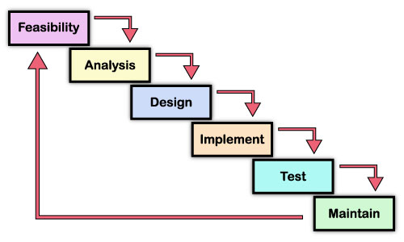

Figure 2.1

System analysis and design focus on the systems, processes and technology. System analysis is the process of gathering and interpreting facts, diagnosing problems, and using the information to recommend improvements to the system. Analysis specifies what the system should do.

System analysis is the dissection of the system into its components pieces to study how those component pieces interacts and works. We do a systems analysis to subsequently perform a systems synthesis. System analysis is a term that collectively describes the early phases of systems development. There has never been a universally accepted definition. And there has never been agreement on when analysis ends and design begins.

A detailed study of the process must be made by various techniques like interviews, questionnaires etc. The data collected by these sources must be scrutinized to arrive to a conclusion. The conclusion is an understanding of how the system functions. Systems analysis is the survey and planning of the system and project, the study and analysis of the existing business and information system and the definition of business requirements and priorities for a new or improved system. A popular synonym is logical design. Preliminary study is the process of gathering and interpreting facts, using the information for further studies on the system.

**2.2 Feasibility Study**

A feasibility study looks at the viability of an idea with an emphasis on identifying potential problems and attempts to answer one main question: Will the idea work and should you proceed with it?

Before you begin writing your business plan you need to identify how, where, and to whom you intend to sell a service or product. You also need to assess your competition and figure out how much money you need to start your business and keep it running until it is established.

Feasibility studies address things like where and how the business will operate. They provide in-depth details about the business to determine if and how it can succeed, and serve as a valuable tool for developing a winning business plan.

**Why Arte Feasibility Studies so Important?**

The information you gather and present in your feasibility study will help you:

* List in detail all the things you need to make the business work;
* Identify logistical and other business-related problems and solutions;
* Develop marketing strategies to convince a bank or investor that your business is worth considering as an investment; and
* Serve as a solid foundation for developing your business plan.

Even if you have a great business idea you still have to find a cost-effective way to market and sell your products and services. This is especially important for store-front retail businesses where location could make or break your business. For example, most commercial space leases place restrictions on businesses that can have a dramatic impact on income. A lease may limit business hours/days, parking spaces, restrict the product or service you can offer, and in some cases, even limit the number of customers a business can receive each day.

The Components of a Feasibility Study:

Description of the Business: The product or services to be offered and how they will be delivered.

[Market Feasibility:](http://womeninbusiness.about.com/od/freebusinesscourses/a/marketdeasibil.htm) Includes a description of the industry, current market, anticipated future market potential, competition, sales projections, potential buyers, etc.

[Technical Feasibility:](http://womeninbusiness.about.com/od/startingasmallbusiness/a/techfeasibility.htm) Details how you will deliver a product or service (i.e., materials, labor, transportation, where your business will be located, technology needed, etc.).

[Financial Feasibility:](http://womeninbusiness.about.com/od/freebusinesscourses/a/finfeasibility.htm) Projects how much start-up capital is needed, sources of capital, returns on investment, etc.

[Organizational Feasibility:](http://womeninbusiness.about.com/od/freebusinesscourses/a/organizatfeas.htm) Defines the legal and corporate structure of the business (may also include professional background information about the founders and what skills they can contribute to the business).

[Conclusions:](http://womeninbusiness.about.com/od/freebusinesscourses/a/conclusionsfeas.htm) Discusses how the business can succeed. Be honest in your assessment because investors won’t just look at your conclusions they will also look at the data and will question your conclusions if they are unrealistic.

**Steps in feasibility analysis:**

Steps involved in the feasibility analysis are:

* Form a project team and appoint a project leader.
* Prepare system flowcharts.
* Enumerate potential proposed system.
* Define and identify characteristics of proposed system

**2.2.1 Technical Feasibility**

A Study of resource availability that may affect the ability to achieve an acceptable system. This evaluation determines whether the technology needed for the proposed system is available or not.

* Can the work for the project be done with current equipment existing Software technology & available personal?
* Can the system be upgraded if developed?
* If new technology is needed then what can be developed?

**Table 1 some issues to consider when determining technical feasibility**

|  |  |
| --- | --- |
| **Technology Issues** | **Market Issues** |
| * Performance * Ease of learning * Ease of deployment * Ease of support * Operational characteristics * Interoperability with other technologies | * Vendor viability * Alternate sources of the technology, if any |

Table 2.1

The technical needs of the system may include:

* **Front-end and back-end selection**

An important issue for the development of a project is the selection of suitable front-end and back-end. When we decided to develop the project we went through an extensive study to determine the most suitable platform that suits the needs of the organization as well as helps in development of the project.

The aspects of our study included the following factors.

* **Front-end selection:**

1. It must have a graphical user interface that assists employees that are not from IT background.
2. Scalability and extensibility.
3. Flexibility.
4. Robustness
5. . According to the organization requirement and the culture.
6. Must provide excellent reporting features with good printings support.
7. . Platform independent.
8. Easy to debug and maintain.
9. Event driven programming facility.
10. Front end must support some popular back end like MySql.

According to the above stated features we selected PHP v5.5.6 as the front-end for developing our project.

* **Back-end Selection:**

1. Multiple user support.

2. Efficient data handling.

3. Provide inherent features for security.

4. Efficient data retrieval and maintenance.

5. Stored procedures.

6. Popularity.

7. Operating System compatible.

8. Easy to install.

9. Various drivers must be available.

10. Easy to implant with the Front-end.

According to above stated features we selected MySql Server v5.6.14 as the backend.The technical feasibility is frequently the most difficult area encountered at this stage. It is essential that the process of analysis and definition be conducted in parallel with an assessment to technical feasibility it centers on the existing computer system (hardware, software etc.) and to what extent it can support the proposed system.

**2.2.2 Economic feasibility**

Economic justification is generally the “Bottom Line” consideration for most systems.

Economic justification includes a broad range of concerns that includes cost benefit analysis. In this we weight the cost and the benefits associated with the candidate system and if it suits the basic purpose of the organization i.e. profit making, the project is making to the analysis and design phase.

**Table 2 Potential costs and benefits of a software project**

|  |  |  |
| --- | --- | --- |
| **Type** | **Potential Costs** | **Potential Benefits** |
| Quantative | * Hardware/Software upgrades. * Training costs to train developers. * Expected operational costs. | * Reduced operating costs. * Increased revenue from additional sales of the organization services. |
| Qualitative | * Increased employee dissatisfaction from area of change. | * Better response from customers * Positive public reception |

Table 2.2

The financial and the economic questions during the preliminary investigation are verified to estimate the following:

* Cost to conduct a full system investigation.
* The cost of hardware and software for the class of application being considered.
* The benefits in the form of reduced cost.
* The proposed system will give the minute information, as a result the performance is improved which in turn may be expected to provide increased profits.
* This feasibility checks whether the system can be developed with the available funds.

The **Indiatravels**does not require enormous amount of money to be developed. This can be done economically if planned judicially, so it is economically feasible. The cost of project depends upon how much information will be containing it.

**2.2.3 Operational Feasibility**

It is mainly related to human organizations and political aspects. The points to be considered are:

* What changes will be brought with the system?
* What organization structures are disturbed?
* What new skills will be required?

**Table 3 Issues to consider when determining the operational feasibility of a project.**

|  |  |
| --- | --- |
| Operations Issues | Support Issues |
| * What tools are needed to support operations? * What skills will operators need to be trained in? | * What documentation will users be given? * How will change be managed? |

Table 2.3

**2.2.4Schedule Feasibility**

**Schedule Feasibility** is defined as the probability of a project to be completed within its scheduled time limits, by a planned due date. If a project has a high probability to be completed on-time, then its schedule feasibility is appraised as high. In many cases a project will be unsuccessful if it takes longer than it was estimated: some external environmental conditions may change, hence a project can lose its benefits, expediency and profitability. If a work to be accomplished at a project does not fit the timeframes demanded by its customers, then a schedule is unfeasible (amount of work should be reduced or other schedule compression methods applied).

If the project managers want to see their projects completed before they can lose their utility, they (project managers) need to give proper attention to controlling their schedule feasibility: to calculate and continually reexamine whether it is possible to complete all amount and scope of work lying ahead, utilizing the given amount of resources, within required period of time. Schedule feasibility study includes use of the following matters:

* Project Estimation;
* Gantt and PERT charts;
* CPM (Critical Path Method);
* Change Management;

**2.2.5 Resource Feasibility**

It includes questions regarding time required to complete the project, type and amount of **resources** required and dependent factors. It also takes care whether the project is interrupting any current business activity.

**2.2.6 Cultural Feasibility**

A **cultural feasibility** study is known as one that investigates all the environmental factors involved to successfully carry out a project. It is done to evaluate the impact of the project on the local **culture**.

**2.2.7 Legal/Ethical Feasibility**

**Legal feasibility** determines whether the proposed system conflicts with **legal**requirements, e.g., a data processing system must comply with the local data protection regulations and if the proposed venture is acceptable in accordance to the laws of the land.

**2.2.8Marketing Feasibility**

A **market feasibility** study determines the depth and condition of a particular real estate **market** and its ability to support a particular development. The key concern of a **market feasibility** study for multifamily development is a project's ultimate marketability.

**2.2.9 Managerial Feasibility**

Managerial feasibility is ascertained by certain key elements like employee involvement, demonstrated management availability & capability and commitment. The managerial and organizational structure of the project is addressed by this feasibility which ensures that the proponent’s structure mentioned in the submittal is feasible to the kind of operation undertaken.

**2.2.10 Social Feasibility**

The affect that a proposed project may have on the social system in the project environment is addressed in the social feasibility. It may happen that particular category of employees may be short or not available as a result of ambient social structure. The influence on the social status of the participants by the project should be evaluated in order to guarantee compatibility. It must be identified that employees in the particular industries may have specific status symbols within the society.

**2.2.11 Safety Feasibility**

Another important aspect that must be considered in the project planning is the safety feasibility. Safety feasibility involves the analysis of the project in order to ascertain its capacity to implement & operate safely with least unfavorable effects on the environment. Mostly in complex projects, environmental impact assessment is not properly addressed.

**2.2.12 Political Feasibility**

The directions for the proposed project are mostly dictated by the political considerations. This is certainly correct for large projects with potential visibility that may have important political implications and government inputs. For example, regardless of the merit of project, the political necessity may be a source of assistance for a project. On the other hand because of political factors, value able projects may face uncontrollable opposition. An evaluation of the objectives of project with the current objectives of the political system is required in the political feasibility analysis.

**2.2.13 Environmental Feasibility**

Environmental aspect is very crucial in making any potential project successful or failed. In the very early stages of the project, this aspect should be considered. All the environmental concerns raised or forecasted should be addressed in environmental feasibility so that proper actions can be taken to cover relevant issues of the environment. The ability of the project to timely acquire the required permits, licenses and approvals at a reasonable cost should also be included in this area.

**2.3 Performance Requirements**

* Speed:

The system developed is more efficient since the connection is made through RDO faster access to data is made possible. The system developed was used by nearly 10 to 12 potential users at a time and consistency is maintained to the maximum.

* Flexibility:

The system is flexible enough to adapt to changing technology as well as change

in business and user requirement.

* Reliability:

The system provides a high degree of resilience and overall reliability. The system incorporates redundancy in critical components and ensures that there is no single point of failures.

* Security:

The system provides the necessary features to ensure that the access of information is protected based on the user.

* Easier to use:

Navigating around your computer is easier than errors, thanks to develop options such as single clicking to open files and addition ofbrowse buttons in every window. You can now use multiple monitors with a single dramatically increasing the size of your workspace.

* Faster:

Windows and programs open faster than before. By, using the maintenance wizard, you can easily improve your computer’s speed and efficiency. The power management feature allows newer computer’s to go hibernation mode and awaken stately, file.

**2.4 Development Tools**

* **Front-end and back-end selection :**

An important issue for the development of a project is the selection of suitable front-end and back-end. When we decided to develop the project we went through an extensive study to determine the most suitable platform that suits the needs of the organization as well as helps in development of the project.

The aspects of our study included the following factors.

* **Front-end selection :**

1. . It must have a graphical user interface that assists employees that are not from IT background.
2. Scalability and extensibility.
3. Flexibility.
4. Robustness.
5. According to the organization requirement and the culture.
6. Must provide excellent reporting features with good printings support.
7. . Platform independent.
8. . Easy to debug and maintain.
9. . Event driven programming facility.
10. Front end must support some popular back end like MySql.

According to the above stated features we selected PHP v5.5.6 as the front-end for developing our project

**3.LITERATURE SURVEY**

**3.1 About JAVA**

**Java** is a general-purpose [computer programming language](https://en.wikipedia.org/wiki/Programming_language) that is [concurrent](https://en.wikipedia.org/wiki/Concurrent_computing), [class-based](https://en.wikipedia.org/wiki/Class-based_programming), [object-oriented](https://en.wikipedia.org/wiki/Object-oriented_programming), and specifically designed to have as few implementation dependencies as possible. It is intended to let application developers "[write once, run anywhere](https://en.wikipedia.org/wiki/Write_once,_run_anywhere)" (WORA), meaning that [compiled](https://en.wikipedia.org/wiki/Compiler) Java code can run on all platforms that support Java without the need for recompilation. Java applications are typically compiled to [bytecode](https://en.wikipedia.org/wiki/Java_bytecode) that can run on any [Java virtual machine](https://en.wikipedia.org/wiki/Java_virtual_machine) (JVM) regardless of [computer architecture](https://en.wikipedia.org/wiki/Computer_architecture). As of 2016, Java is one of the most [popular programming languages in use](https://en.wikipedia.org/wiki/Measuring_programming_language_popularity), particularly for client-server web applications, with a reported 9 million developers.[[22]](https://en.wikipedia.org/wiki/Java_(programming_language)#cite_note-22) Java was originally developed by [James Gosling](https://en.wikipedia.org/wiki/James_Gosling) at [Sun Microsystems](https://en.wikipedia.org/wiki/Sun_Microsystems)(which has since been [acquired by Oracle Corporation](https://en.wikipedia.org/wiki/Sun_acquisition_by_Oracle)) and released in 1995 as a core component of Sun Microsystems' [Java platform](https://en.wikipedia.org/wiki/Java_(software_platform)). The language derives much of its [syntax](https://en.wikipedia.org/wiki/Syntax_(programming_languages)) from [C](https://en.wikipedia.org/wiki/C_(programming_language)) and [C++](https://en.wikipedia.org/wiki/C%2B%2B), but it has fewer [low-level](https://en.wikipedia.org/wiki/Low-level_programming_language) facilities than either of them.

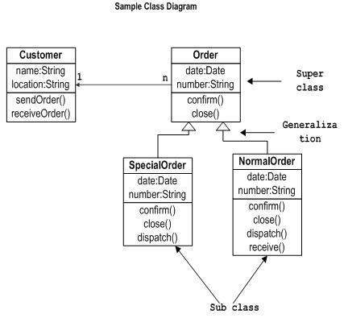

Figure 3.1

The original and [reference implementation](https://en.wikipedia.org/wiki/Reference_implementation) Java [compilers](https://en.wikipedia.org/wiki/Compiler), virtual machines, and [class libraries](https://en.wikipedia.org/wiki/Library_(computing)) were originally released by Sun under proprietary licenses. As of May 2007, in compliance with the specifications of the [Java Community Process](https://en.wikipedia.org/wiki/Java_Community_Process), Sun [relicensed](https://en.wikipedia.org/wiki/Software_relicensing) most of its Java technologies under the [GNU General Public License](https://en.wikipedia.org/wiki/GNU_General_Public_License). Others have also developed alternative implementations of these Sun technologies, such as the [GNU Compiler for Java](https://en.wikipedia.org/wiki/GNU_Compiler_for_Java) (bytecode compiler), [GNU Classpath](https://en.wikipedia.org/wiki/GNU_Classpath) (standard libraries), and [IcedTea](https://en.wikipedia.org/wiki/IcedTea)-Web (browser plugin for applets).

The latest version is [Java 9](https://en.wikipedia.org/wiki/Java_version_history), released on September 21, 2017,[[23]](https://en.wikipedia.org/wiki/Java_(programming_language)#cite_note-23) and is one of the two versions currently supported for free by Oracle. Versions earlier than Java 8 are supported both by Oracle and other companies on a commercial basis.

### 3.1.1 Principles

There were five primary goals in the creation of the Java language:

1. It must be "simple, object-oriented, and familiar".
2. It must be "robust and secure".
3. It must be "architecture-neutral and portable".
4. It must execute with "high performance".
5. It must be "interpreted, threaded, and dynamic".

**3.1.2 How Java Works**

Java is the first substantial language which is neither truly interpreted nor compiled; instead, a combination of the two forms is used. This method has advantages which were not present in earlier languages.

**3.1.3 Platform-Independence**

To understand the primary advantage of Java, you'll have to learn about *platforms*. In most programming languages, a compiler (or interpreter) generates code that can execute on a specific *target* machine. For example, if you compile a C++ program on a Windows machine, the executable file can be copied to any other machine but it  will only run on other Windows machines but never another machine (e.g., a Mac or a Linux machine). A platform is determined by the target machine (along with its operating system). For earlier languages, language designers needed to create a specialized version of the compiler (or interpreter) for every platform. If you wrote a program that you wanted to make available on multiple platforms, you, as the programmer, would have to do quite a bit of additional work.  You would have to create multiple versions of your source code  for each platform.

Java succeeded in eliminating the platform issue for high-level programmers (such as you) because it has *reorganized* the compile-link-execute sequence at an underlying level of the compiler. Details are complicated but, essentially, the designers of the Java language isolated those programming issues which are dependent on the platform and developed low-level means to abstractly refer to these issues. Consequently, the Java compiler doesn't create an object file, but instead it creates a ***bytecode***file which is, essentially, an object file for a *virtual machine*.  In fact, the Java compiler is often called the JVM compiler (for Java Virtual Machine).

Consequently, you can write a Java program (on any platform) and use the JVM compiler (called javac) to generate a bytecode file (bytecode files use the extension .class). This bytecode file can be used on any platform (that has installed Java). However, bytecode is not an executable file.  To execute a bytecode file, you actually need to invoke a Java interpreter (called java). Every platform has its own Java interpreter which will automatically address the  platform-specific issues that can no longer be put off. When platform-specific operations are required by the bytecode, the Java interpreter links in appropriate code specific to the platform.

To summarize how Java works (to achieve platform independence), think about the compile-link-execute cycle. In earlier programming languages, the cycle is more closely defined as "compile-link then execute". In Java, the cycle is closer to "*compile then link-execute*".

As with interpreted languages, it is possible to get Java programs to run faster by compiling thebytecode into an executable; the disadvantage is that such executables will only work on the platform in which it is created.

**3.1.4 Other Advantages of Java**

Most of the other features of Java had previously existed in various other programming languages (but never all at once).  Most explanations of these advantages (e.g., distributed programming, multi-threading, security) are well beyond the scope of this course. However, there are two features that I will briefly address.

Another feature that was introduced with the Java language is the ability to write special Java programs (called *applets*) that are designed to run on the World Wide Web. You could write a Java applet and put the bytecode on a web page; if anyone with a Java-enabled web browser goes to your web page, that applet bytecode will be downloaded to the browsing computer and executed within the web browser. Of course, this would not be possible without platform independence. This feature had a major effect on the rapid proliferation of Java and many instructors (including myself) taught programming using applet-based programs. However, for a variety of reasons, I have decided to postpone a discussion of applets (and more generally, graphic user interfaces) to the end of the course.

Java is also one of the first languages to be "*library-based*" in that the designers of the language have included a large number of pre-existing programs. A programmer can connect their program to these general purpose programs as needed. It frees up the programmer's time since s/he doesn't have to write as much code. We'll start exploring this library called the ***API***  (application programmer interface) after we learn a substantive amount of the Java language itself.

* **Back-end Selection:**

1. Multiple user support.

2. Efficient data handling.

3. Provide inherent features for security.

4. Efficient data retrieval and maintenance.

5. Stored procedures.

6. Popularity.

7. Operating System compatible.

8. Easy to install.

9. Various drivers must be available.

10. Easy to implant with the Front-end.

According to above stated features we selected MySql Server v5.6.14 as the backend.

The technical feasibility is frequently the most difficult area encountered at this stage. It is essential that the process of0 analysis and definition be conducted in parallel with an assessment to technical feasibility it centers on the existing computer system (hardware, software etc.) and to what extent it can support the proposed system

**3.2 The WEB and HTML**

World Wide Web (WWW) programming deals with the development of hypertext document interaction mechanisms, which provide the client with a rich and intuitive interface to the information that he or she desires to view. Web development heavily utilizes the functionality of the Hypertext Markup Language, commonly known as HTML. HTML is a simple scripting language that is interpreted within a web browser. It provides functionality to identify and specify how information is presented to the user. Some of the important features of HTML that make it ideal for online representation of information are –

* Ease of Use – HTML constructs are very easy to comprehend, and can be used effectively by anybody.
* Machine Independence – The methodology used by HTML to mark up information is independent of its representation on a particular hardware or software architecture.
* Standardization – HTML syntax is a worldwide standard, developed by the W3C
* Flexible – HTML has been extended in many forms to provide additional functionality

**3.3 Java Script**

Java script is one of the most simple, versatile and effective languages used to extend functionality in websites. Uses range from on screen visual effects to processing and calculating data on web pages with ease as well as extended functionality to websites using third party scripts among several other handy features, however it possesses some negative effects that might make you want to think twice before implementing JavaScript on your website.

**3.3.1 Advantages**

* **JavaScript is executed on client side**   
  this means that the code is executed on the user's processor instead of the web server thus saving bandwidth and strain on the web server.
* **JavaScript is relatively easy language**   
  The JavaScript language is relatively easy to learn and comprises of syntax that is close to English. It uses the DOM model that provides plenty of prewritten functionality to the various objects on pages making it a breeze to develop a script to solve a custom purpose.
* **JavaScript is relatively fast to end users**   
  As the code is executed on the user's computer, results and processing is completed almost instantly depending on the task as it does not need to be processed in the site's web server and sent back to the user consuming local as well as server bandwidth.
* **Extended functionality to web pages**   
  Third party add-ons like Grease monkey enable JavaScript developers to write snippets of JavaScript which can execute on desired web pages to extend its functionality. If you use a website and require a certain feature to be included, you can write it yourself and use an add-on like grease monkey to implement it on the web page.

**3.3.2 Disadvantages**

**Security Issues:**

JavaScript snippets, once appended onto web pages execute on client servers immediately and therefore can also be used to exploit the user's system. While certain restriction is set by modern web standards on browsers, malicious code can still be executed complying with the restrictions set.

**3.4 MySql**

Among the many application development and end user products available within the MYSQL family there is a common ability to access the database. Whether directly or in directly this is achieved through the Structured Query Language (SQL). These query languages have been useful in developing the software in an efficient way. The Query language has Data Definition Language (DDL), Data Manipulation Language (DML) and Data Control Language (DCL).

**Data definition language** helps in defining various database objects such as Tables and views. This has been useful in defining all the relational tables of the project. It has also been used in creating many views providing for information hiding and data security. Data Definition Language (DDL) also supports alteration of the existing tables.

**Data Manipulation Language** (DML) is the most important of the query Language. This has features for inserting records into the tables, deleting the existing records from the tables, updating the existing records in the tables and retrieving the data from one or more tables as and when required. This has been used to fulfill the objectives of the organization. Other packages like FoxPro and Dbase do not have such features and hence make the job of querying more complex.

**Data Control Language** (DCL) is used for controlling data and having access to the databases. This part of the language provides extensive security features in order to safe guard the users information from both unauthorized access and intentional damage. Granting and revoking privileges provide security. Oracle uses have names and passwords and own tables, views and other database object

| Character Data Types | | |
| --- | --- | --- |
| **Data Types** | **Description** | **Range/Format** |
| CHAR | Fixed-length string | 0–255 characters. |
| VARCHAR | Variable-length string | 0–255 characters. |
| BLOB | Binary Large Object (BLOB) | Binary data 0–65535 bytes long. |
| TINYBLOB | Small BLOB value | Binary data 0–255 bytes long. |
| MEDIUMBLOB | Medium-sized BLOB | Binary data 0–16777215 bytes long. |
| LONGBLOB | Large BLOB value | Binary data 0–4294967295 bytes long. |
| TEXT | Normal-sized text field | 0–65535 bytes. |
| TINYTEXT | Small text field | 0–255 bytes. |
| MEDIUMTEXT | Medium-sized text | 0–16777215 bytes. |
| LONGTEXT | Large text field | 0–4294967295 bytes. |
| ENUM | Enumeration | Column values are assigned one value from a set list. |
| SET | Set value(s) | Column values are assigned zero or more values from a set list. |

Table 3.1

| SQL Modifiers | |
| --- | --- |
| **Modifier** | **Description** |
| AUTO_INCREMENT | Allows a numeric column to be automatically updated when records are added. Useful for creating a unique identification number for each row. |
| DEFAULT value | Specifies the default value for a column. |
| NULL | Specifies that a column may contain undefined, or NULL, values. |
| NOT NULL | Requires that the column must contain a non-NULL value. |
| PRIMARY KEY | Makes the column the primary key. It must also have a NOT NULL modifier. |

Table 3.2

**3.4.1 Sql Server**

SQL Server is an SQL-compliant RDBMS. SQL-compliant means it use the ANSI (American National Standard Institute) version of Structured Query Language or ‘SQL’. Structured Query Language is a command that allow us to modify or retrieve information from the database.

Client server means that SQL Server is designed to store data in the central location (the server) and deliver it on demand to numerous other locations (the client). SQL Server is also a Relational Database Management System (RDBMS).

**3.4.2 Features of SQL Server**

* Information representation
* Unique definition of rows
* Systematic treatment of Null values
* Guaranteed access
* High level Update, Insert, and Delete
* Retrieving information from the database.
* Accepting query language statements.
* Enforcing security specifications.
* Enforcing data integrity specification
* Enforcing transaction consistency
* Managing data sharing
* Optimizing queries
* Managing System catalogs

**3.4.3 Enterprise Manager**

SQL Server Enterprise Manager is a graphical tool that allows easy configuration and management of Microsoft SQL Server and SQL program group.

SQL Server Enterprise Manager can also be used to:

1. Manage logins, permission and users.

2. Create a database

3. Take back-up of database and transaction logs.

4. Manage tables

**3.4.4 Query Analyzer**

The SQL Server Query Analyzer allows us to create adhoc queries and run them interactively. We may also execute Transact-SQL statements stored in text file and view the result in result plane or result grid. The Query Analyzer also has a color-coded editor to assist the user with checking of syntax. It also has context sensitive help.

**4.REQUIREMENT AND SPECIFICATION**

**4.1 Software Requirements Specification**

OPERATING SYSTEM: Windows 10

LANGUAGE (FRONT END): CORE JAVA

LANGUAGE (BACK END): MYSQL

SOFTWARE DESIGINING: NETBEANS

SOFTWARE DATA STORING: XAMPP

BROWSER: GOOGLE CHROME/MOZILA FIREFOX/MICROSOFT EDGES

**4.2 Hardware Requirements Specification**

PROCESSOR I3

RAM 2GB for developer & 4 GB for production use.

HARD DISK80GB

**5.SYSTEM DESIGN**

**5.1 System Specifications**

System specification documents most predominantly contain information on basic requirements which include:

➢ Performance levels

➢ Reliability

➢ Quality

➢ Interfaces

➢ Security and Privacy

➢ Constraints and Limitations

➢ Functional Capabilities

➢ Data Structures and elements

**5.2 Data Flow Diagrams**

It is a way of expressing system requirement in a graphical form; this leads to a modular design. It is also known as bubble chart, it has the purpose of clarifying system requirements and identifying major transformations that will become program in system design. So it is the starting point of the design phase that functionally decomposes the requirement specifications down to the lowest level of details. A DFD consist of a series of bubbles joined by lines. The bubbles represent data transformation and the lines represent data flows in the system.

At level 0 DFD, also called fundamental system model or a context model, represents the entire software element as single bubble with input and output data indicated by incoming and outgoing arrows respectively. Additional bubble and information flow paths are represented as level 0 DFD is partitioned to reveal more details.

**5.2.1 DFD Symbols**

Source or Destination of data

Data flow

Store Data

Process

Entity relationship diagram depicts the relationship between entities and attributes of the user. Friends with the help of username and can be able to search those users who are already got registered on the site. The user also could able to able to update or delete his information such as basic information etc. which further will save in the database. As well as the admin can authenticate the user, modify, update, delete and can handle the system

We have specified the design of our present system in three stages in SDLC:

1. Input Design
2. Output Design
3. Database Design

**Data Flow Diagram** (**DFD**) is a graphical representation of the "flow" of data through an information system. A DFD is often used as a preliminary step to create an overview of the system. DFDs can also be used for the visualization of data processing (structured design).

A DFD shows what kind of information will be input to and output from the system, where the data will come from and go to, and where the data will be stored. It does not showinformationabout the timing of process or information about whether processes will operate in sequence or in parallel.

5.2.2 History

Data flow diagrams were proposed by Larry Constantine. The original developer of structured design, based on Martin and Estrin's "Data Flow Graph" model of computation. Starting in the 1970s, data flow diagrams (DFD) became a popular way to visualize the major steps and data involved in software system processes. DFDs were usually used to show data flows in a computer system, although they could in theory be applied to business process modeling. DFD were useful to document the major data flows or to explore a new high-level design in terms of data flow.

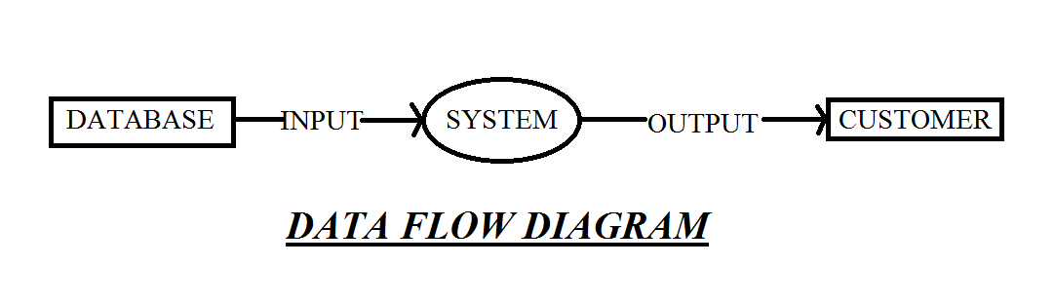

Figure 5.1

**5.2.3 Data flow diagram Symbols:**

External entities: rectangular box

Data flow: arrow headed lines

Process/ function: bubble/ circle.

Data store: narrow opened rectangle.

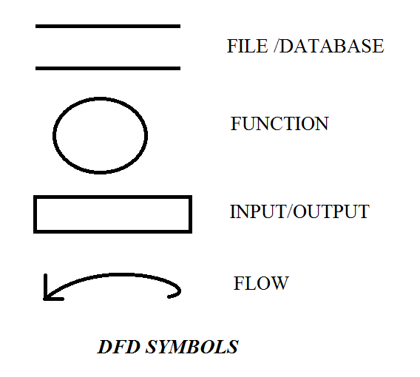

Figure 5.2

**A data flow diagram represents the following**

External devices sending or receiving data.

Processes that change the data.

Data flow themselves.

data storage locations.

**Types of data flow diagram**

There are two types of data flow diagrams, namely physical data flow diagrams and logical data flow diagram and it is important to difference between the two:

**1.Physical data flow diagram**

An implementation dependent view of the current system, showing what tasks are carried out and how they are performed. Physical characteristic can include:

Names of people.

Form and document name and number.

Name of departments.

Master and transaction files.

Equipment and device used.

Locations.

Names of procedures.

**2.Logical data flow diagram**

An implementation independent view of the system, focusing on the flow of data between processes without regard for the specific devices, storage location or people in the system. The physical characterstics listed above for physical data flow diagram will not be specified.

**Data Flow Diagrams  
Admin Level**

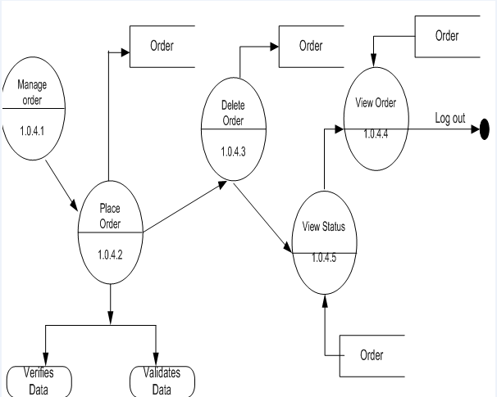

Figure 5.3

**User End DFD**

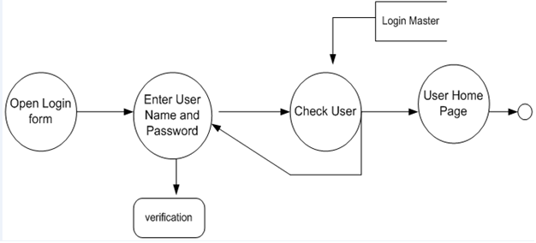

Figure 5.4

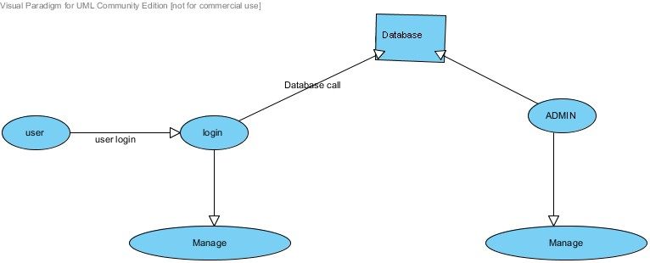

Figure 5.5

**5.3E-R DIAGRAM**

Entity Relationship Diagrams are a major data modeling tool and will help organize the data in your project into entities and define the relationships between the entities. This process has proved to enable the analyst to produce a good database structure so that the data can be stored and retrieved in a most efficient manner.

**5.3.1 Entity**

A data entity is anything real or abstract about which we want to store data. Entity types fall into five classes: roles, events, locations, tangible things or concepts. E.g. employee, payment, campus, book. Specific examples of an entity are called **instances.** E.g. the employee John Jones, Mary Smith's payment, etc.

**5.3.2 Relationship**

A data relationship is a natural association that exists between one or more entities. E.g. Employees process payments. .

**5.3.3 Attributes**

A data attribute is a characteristic common to all or most instances of a particular entity. Synonyms include property, data element, and field. E.g. Name, address, Employee Number, pay rate are all attributes of the entity employee. An attribute or combination of attributes that uniquely identifies one and only one instance of an e

ntity is called a **primary key** or **identifier**. E.g. Employee Number is a primary key for Employee.

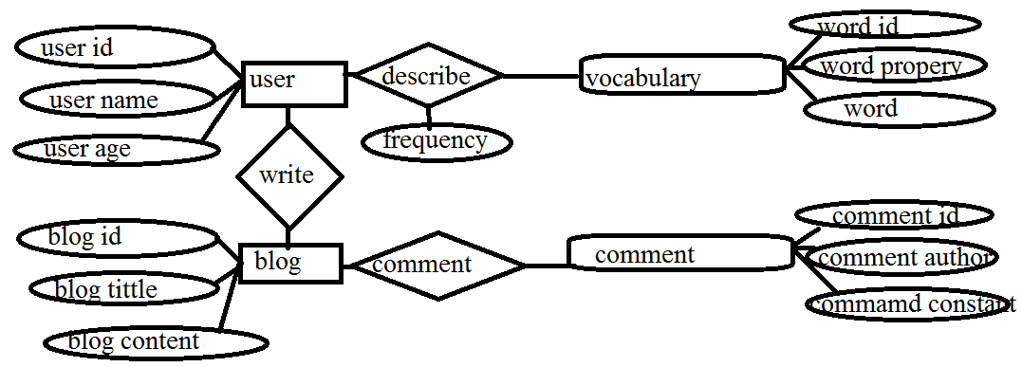

Figure 5.6

***Snapshots of Project:***

**First Log In Privilege Page**

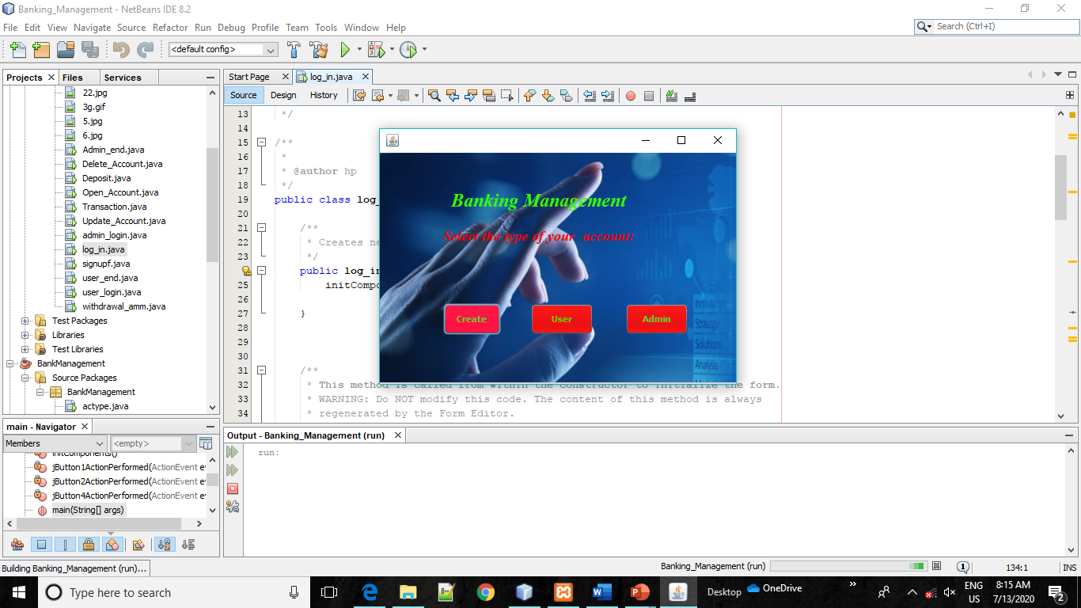

**Create New Account:**

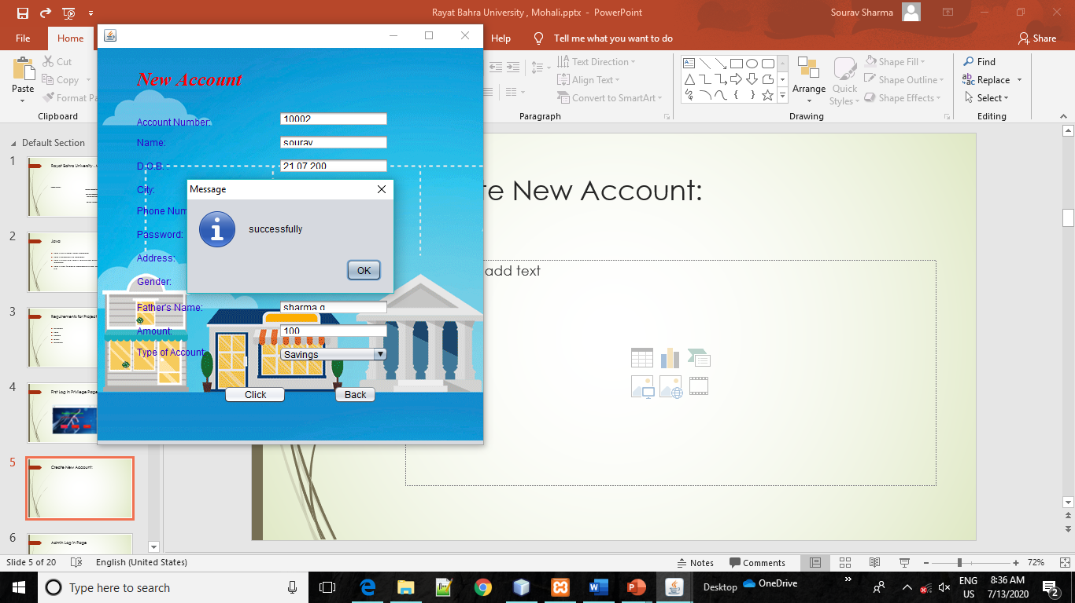

**Admin Log in Page**

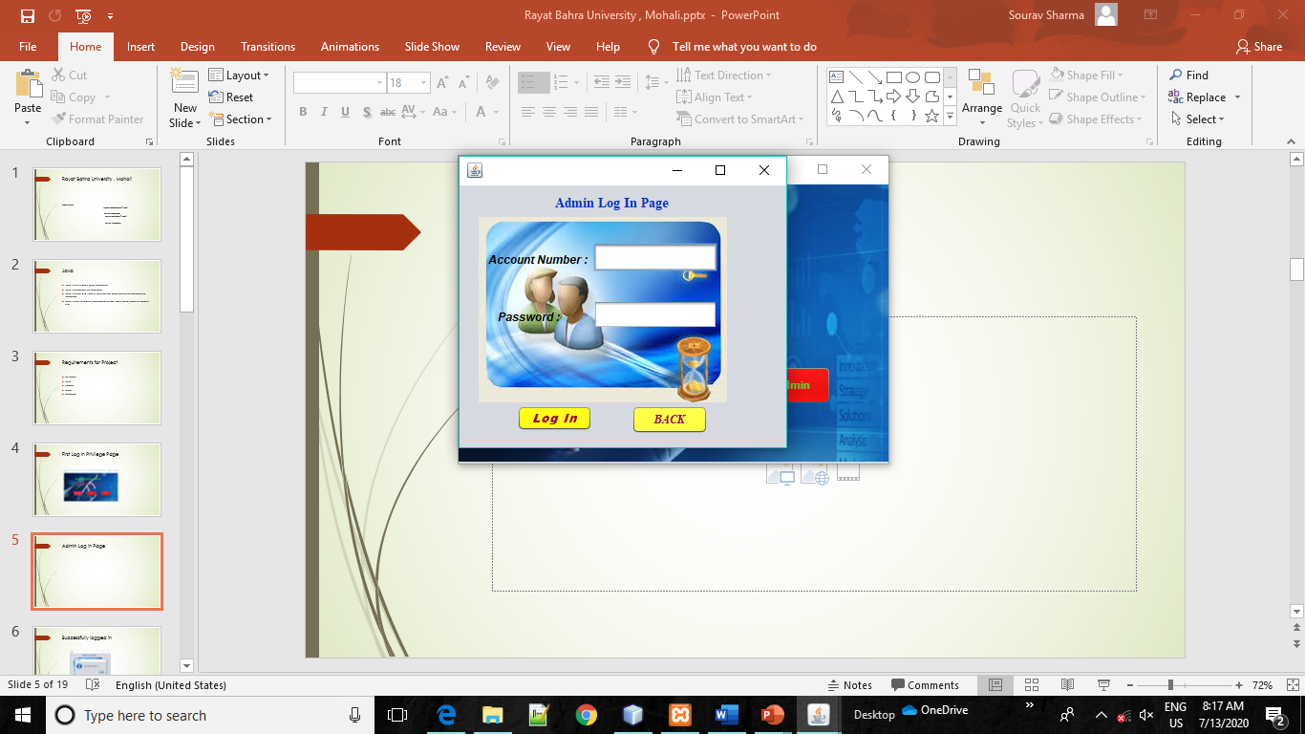

**Successfully logged in**

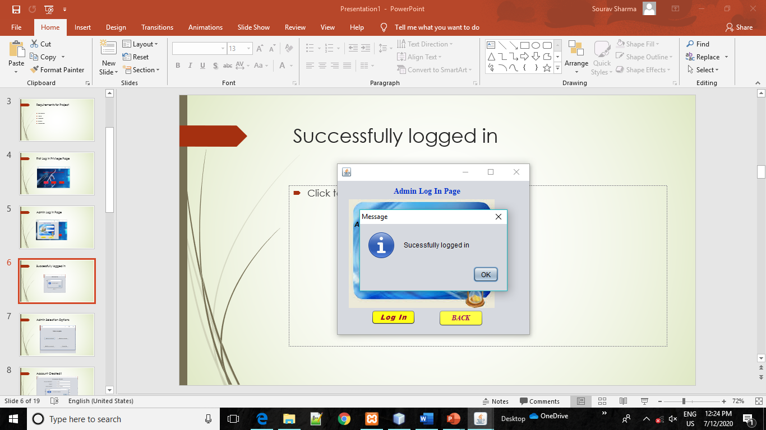

**Admin Selection Options**

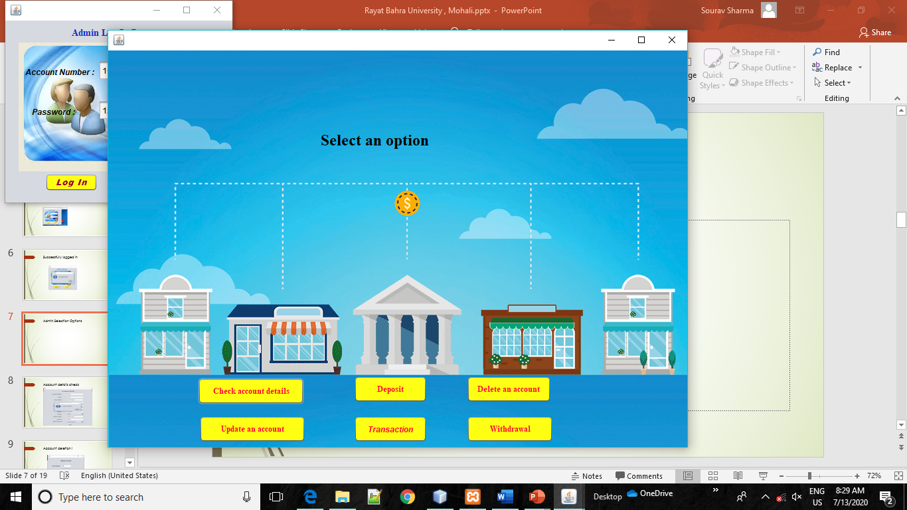

**Account details check**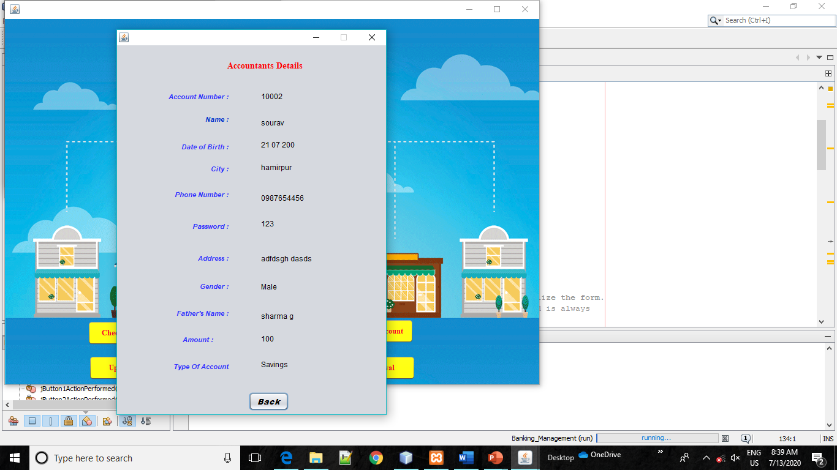

**Amount Deposit:**

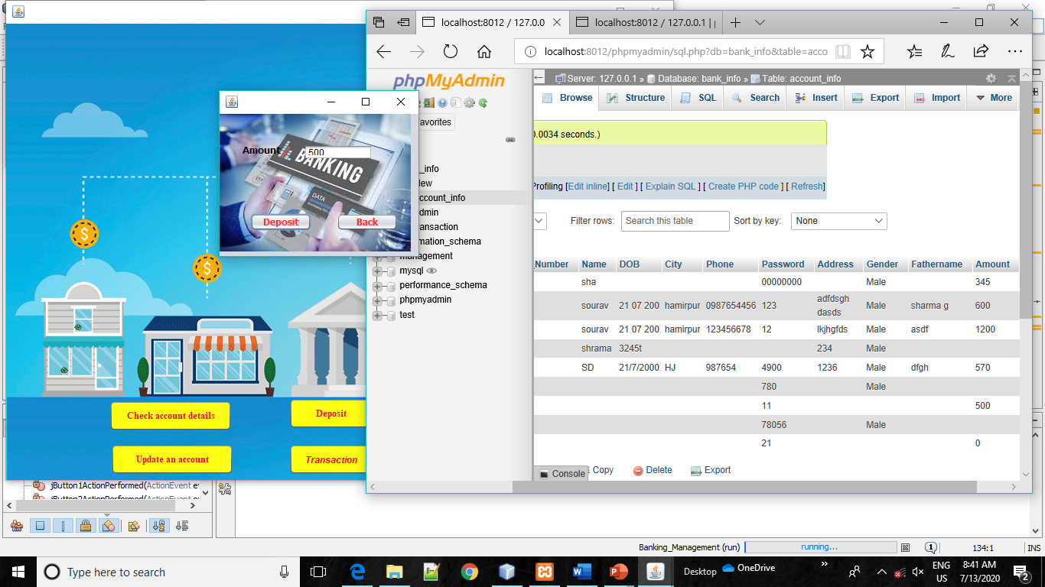

**Account deletion !**

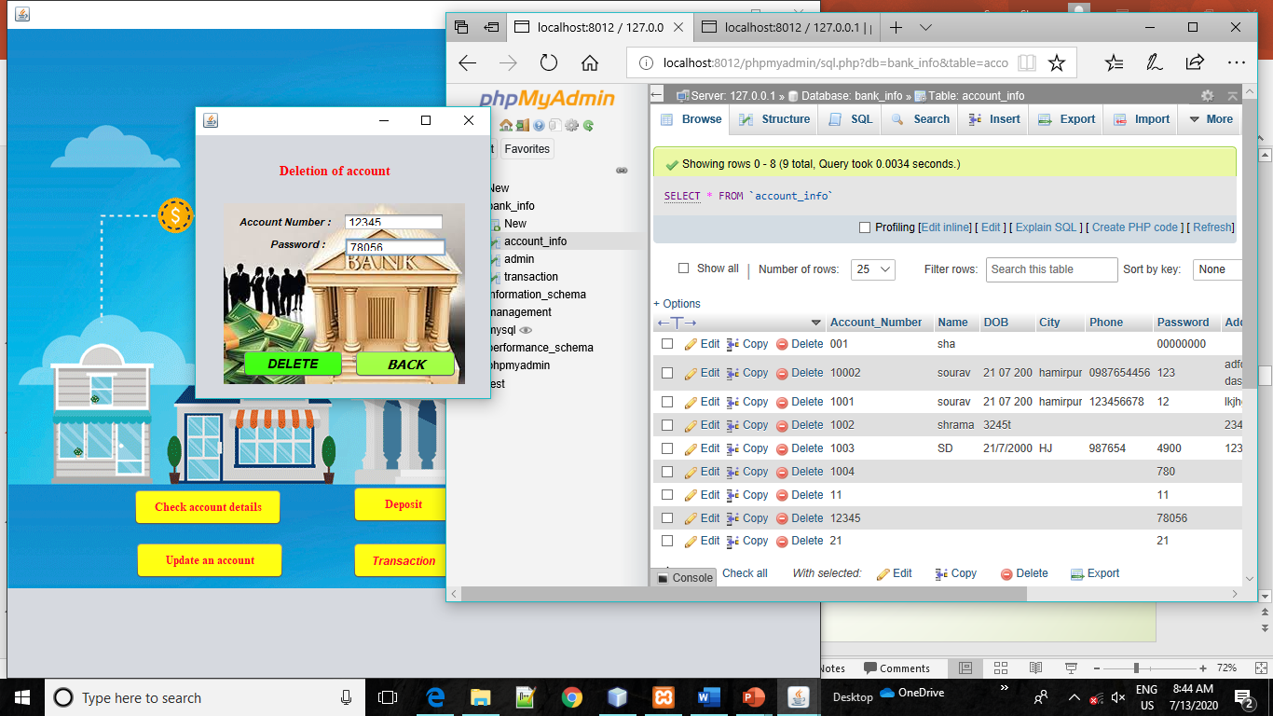

**Deletion confirmation!**

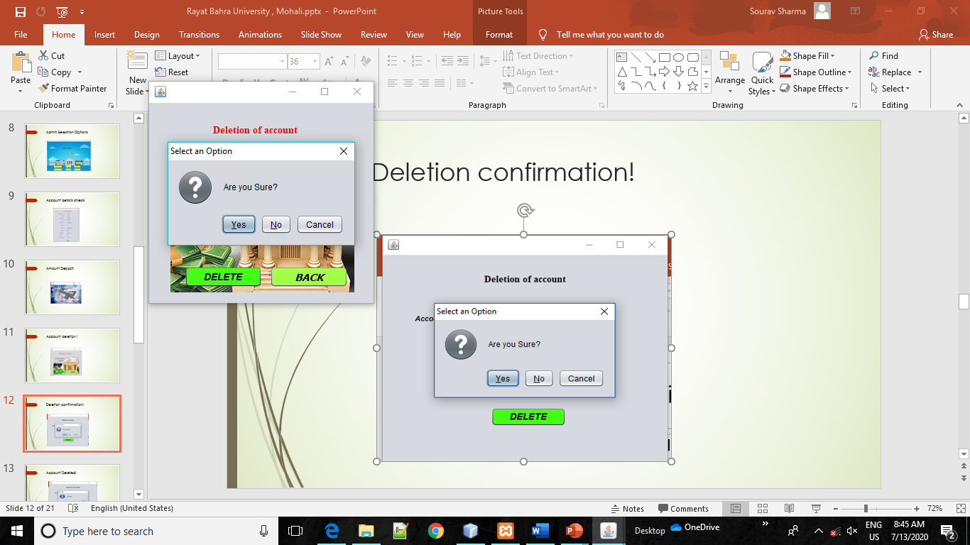

**Account Deleted!**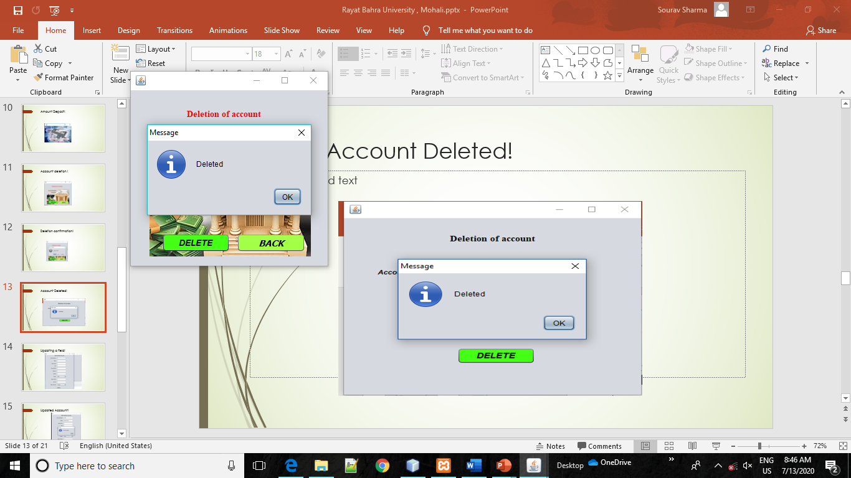

**Updating a field!**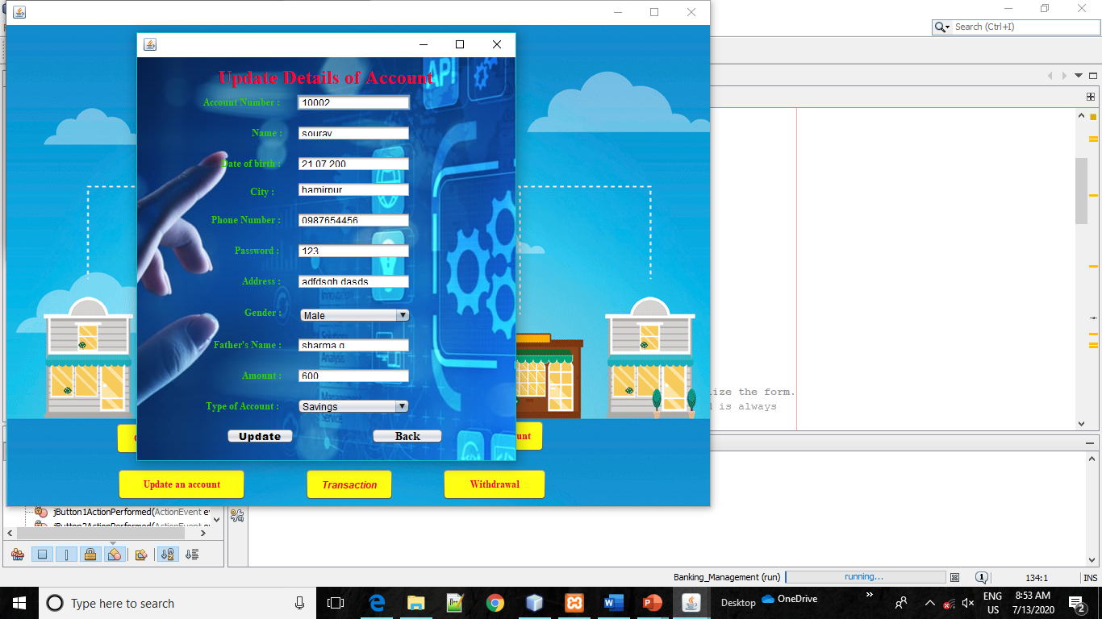

**Updated Account!**

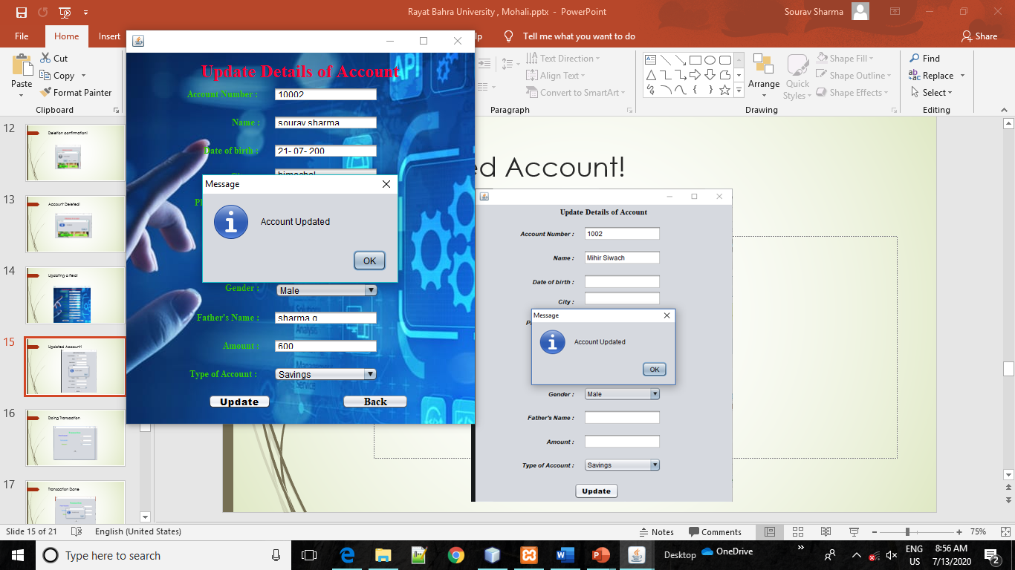

**Doing Transaction** 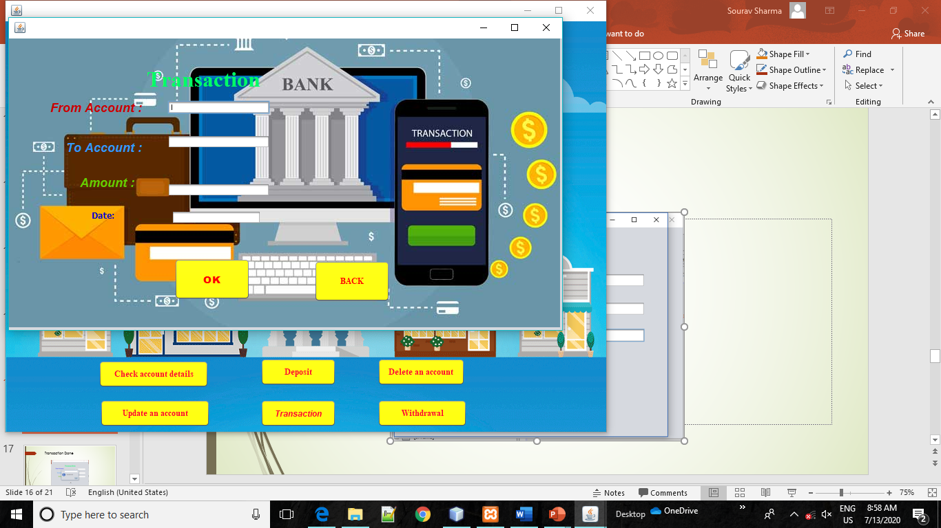

**Transaction Done**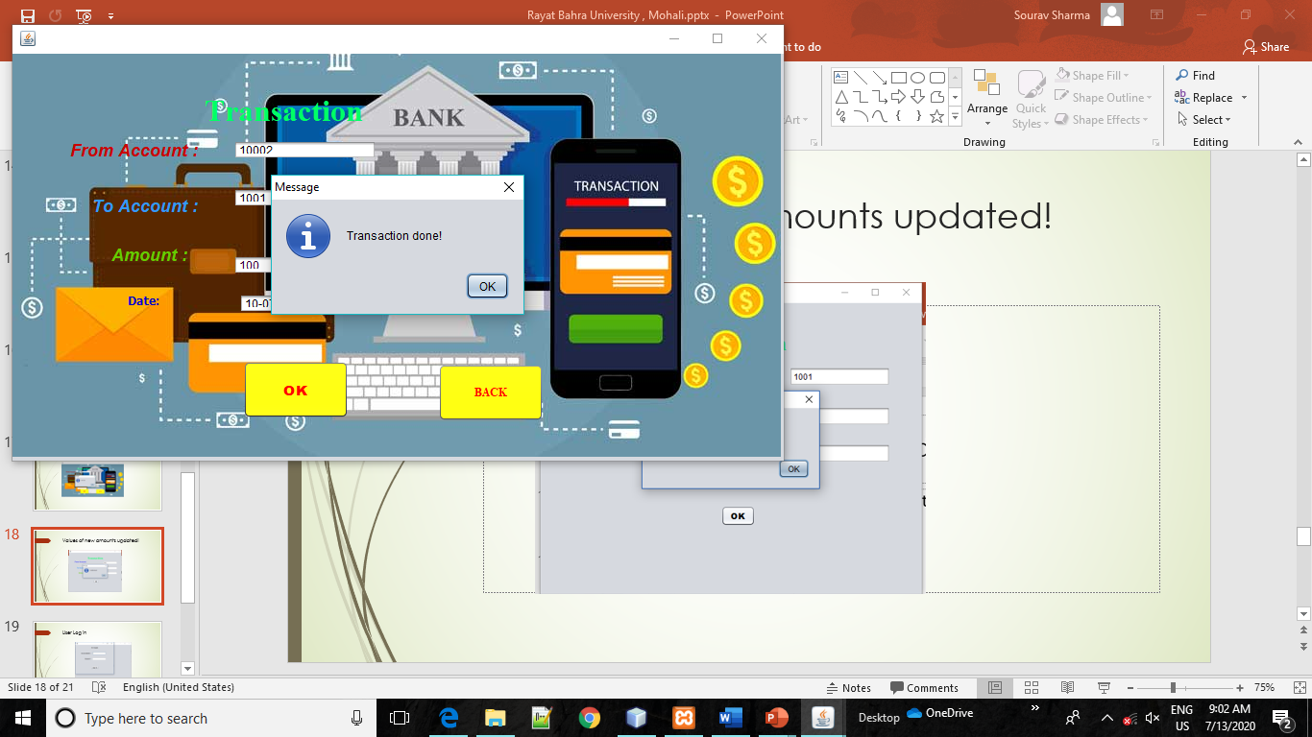

**Values of new amounts updated!**

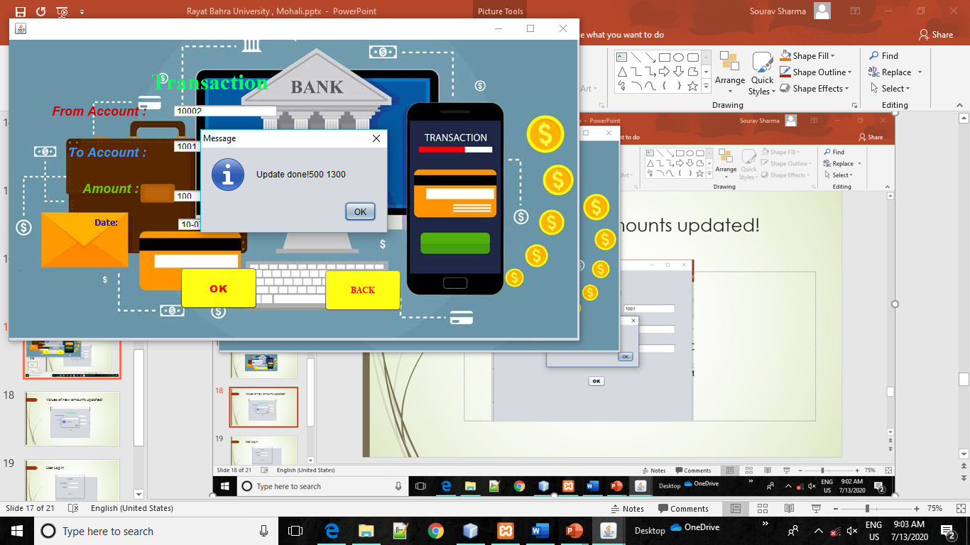

**Withdrawal Amount:**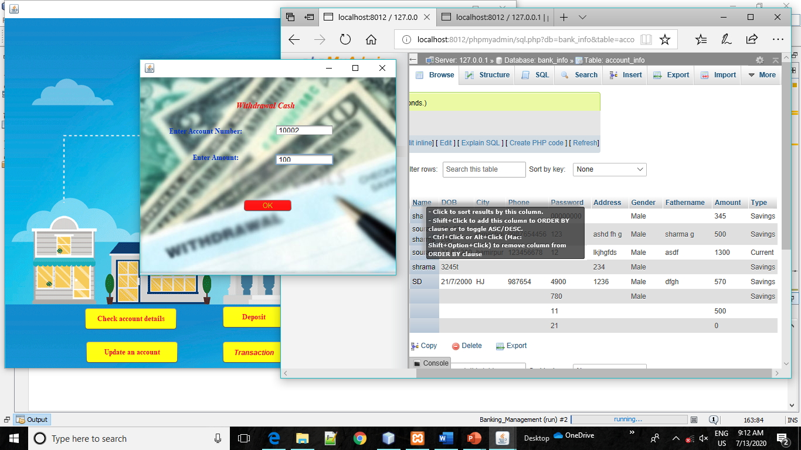

**Successfully Withdrawal:**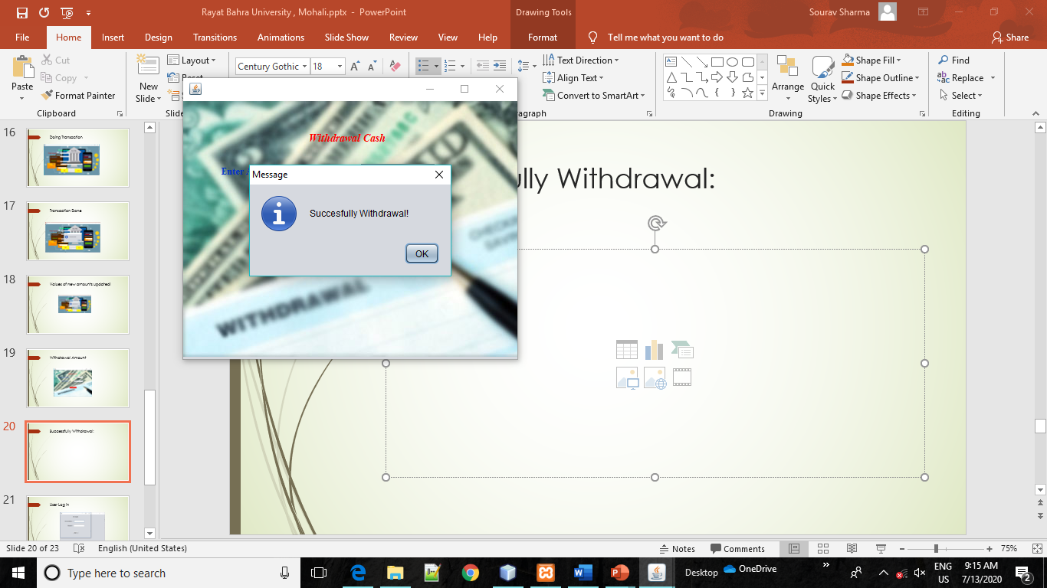

**User Log in**

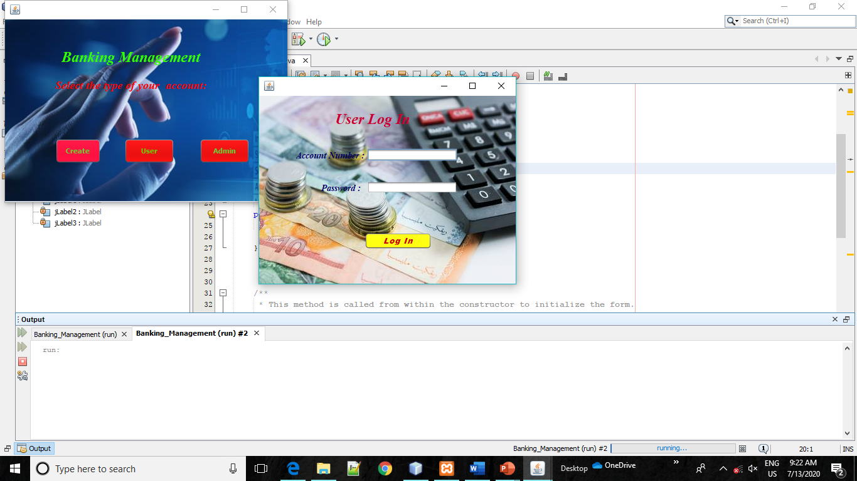

**User logged In:**

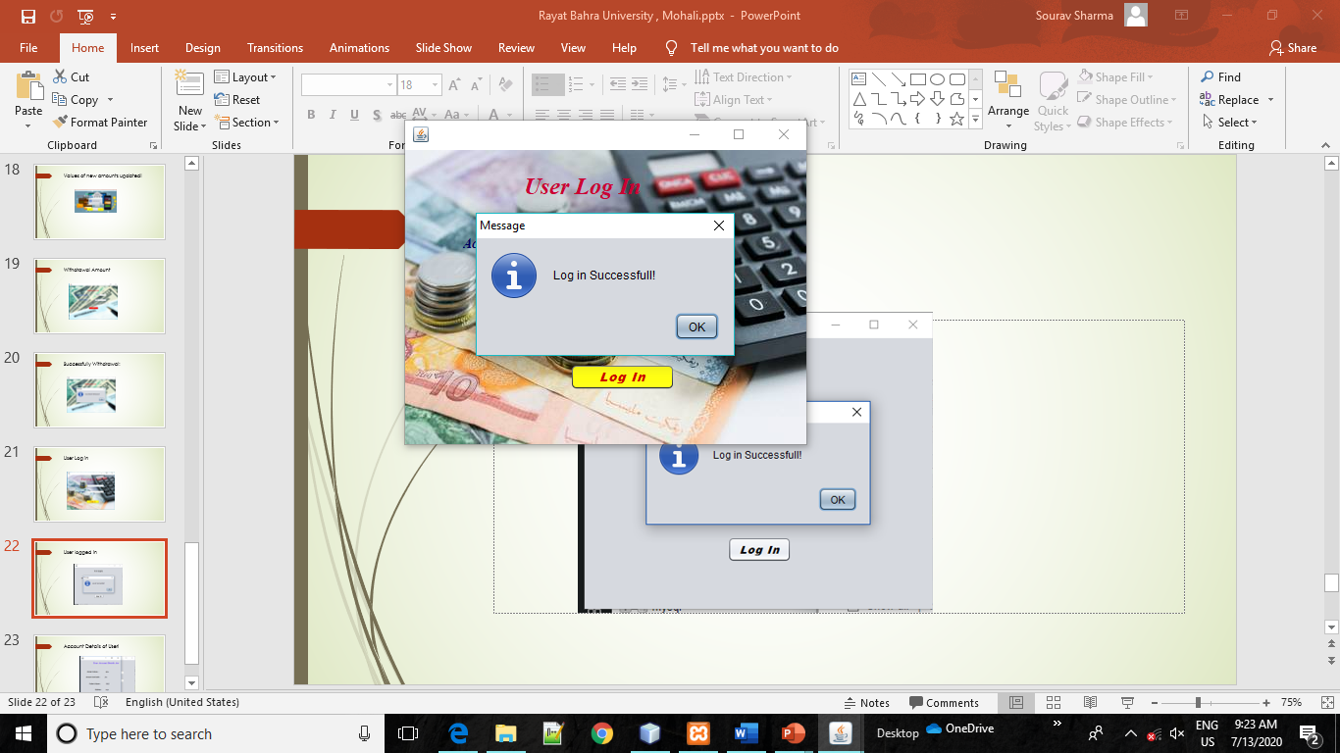

**Account Details of User!**

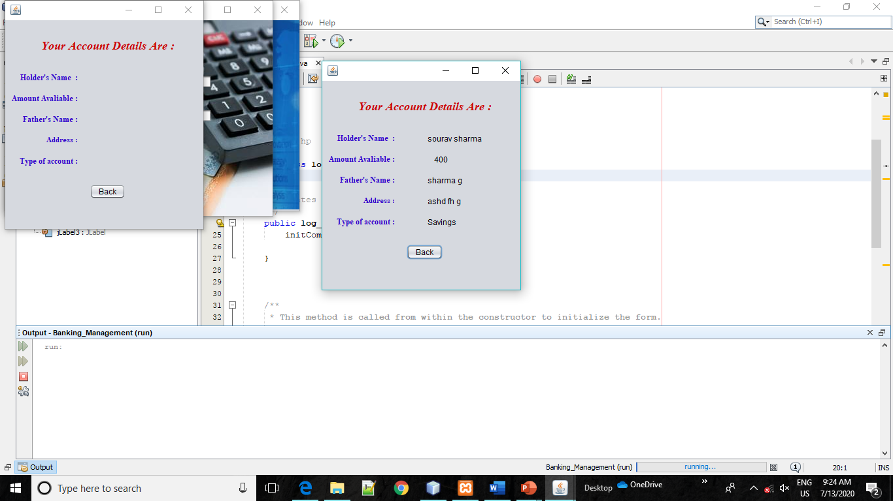

**IMPLEMENTATION**

The implementation phase is less creative than system design. It is primarily concerned with user training, site preparation and file conversion. During file testing, user acceptance is, tested followed by user training. Depending on the nature of system, extensive user training may be required. Conversion usually takes place at about the same time the user is being trained. Programming is thought to be modified as a result of programming effort. Programming provides a ***“realty test”*** for the assumption made by analyst.

System testing checks the deadlines and accuracy of the system. To access, update and retrieve data from new files. Once the programs become available, test data are read into the computer and processed against the file provided. For testing, it successful program is then run with ***“live”*** data. Otherwise, a diagnostic test to locate and correct errors. In most conversion, parallel run is conducted where the new system simultaneous run both old system. This method, through costly, provided added assurance against errors in the candidate system. This method through costly, provided added assurance against errors in the candidate system and also the user staff an opportunity to gain experience through operation.

**CONCLUSION**

The project titled as **Banking System**is a management system which is designed in Core Java. In this system, we can manage money of their account holder who submitted their money in the bank.This system is very Interesting. This software is developed with scalability in mind. Additional modules can be easily added when necessary.

The software is developed with modular approach. All modules in the system have been tested with valid data and invalid data and everything work successfully. Thus the system has fulfilled all the objectives identified and is able to replace the existing system.

The project has been completed successfully with the maximum satisfaction of the organization. The constraints are met and overcome successfully. The system is designed as like it was decided in the design phase. The project gives good idea on developing a full-fledged application satisfying the user requirements.

The system is very flexible and versatile. This software has a user-friendly screen that enables the user to use without any inconvenience. Validation checks induced have greatly reduced errors. Provisions have been made to upgrade the software. The application has been tested with live data and has provided a successful result. Hence the software has proved to work efficiently.

The lessons learnt after developing this project are as follows:

* Before developing any project the requirement should be made well clear so that after developing it the programmer does not have to change it.
* Software and hardware constraints should be kept in mind.
* Time and cost are those constraints, which are never told but always accounted for.
* Project should be error free and made in such a way so that modifications can be done in future.
* A professional should have a vision to see beyond the user-defined requirement.
* All members of the project team have to be cooperative with each other.
* User should be given proper training about how to use project.

**FUTURE SCOPE**

The future of this project depends on whether the author has enough spare time over the next 2 months to continue with the developing. The author feels that last few remaining features would round off the system. If the author was to try to sell this system then more system testing would have to be done, in a particular a more comprehensive real – world. Testing environment would have to be adopted along with some real word’s usage. Multiple concurrent users would be command in real world usage but have been difficult to test for considering there was only tester involved in this project. This type of system would benefit for the hardware in case of a system failure for the software in case of newly found bugs, in return of a subscription free.

* Add another modules/service.
* Add services for customer to update him/herself.

**REFERENCES**

##### **General**

1. Java mother site

@ [http://java.sun.com](http://java.sun.com/) (or <http://www.oracle.com/technetwork/java/index.html>).

1. For XAMPP download: @<https://xampp-windows.en.softonic.com/>

##### **JDK (aka Java SE)**

1. Java SE mother site

@ [http://java.sun.com/javase](http://java.sun.com/javase/) (or <http://www.oracle.com/technetwork/java/javase/overview/index.html>).

1. JDK 7 API Documentation Online

@ <http://download.oracle.com/javase/7/docs/api/index.html>.

1. JDK 7 Documentation Online @ <http://download.oracle.com/javase/7/docs/>.
2. Ken Arnold, James Gosling and David Holmes, "The Java Programming Language", 4th ed, 2005. (The defacto standard for Java Language, but does not seem to have been updated to cover the latest features?!).
3. James Gosling, Bill Joy, Guy Steele and Gilad Bracha, "The Java Language Specification", 3rd ed, 2005. (The defacto standard for JVM, but does not seem to have been updated?!).
4. JDK 7 Demos and Samples (to be downloaded

@ <http://www.oracle.com/technetwork/java/javase/downloads/index.html>).

##### **Books & Online Tutorials**

1. The online Java tutorial @ <http://docs.oracle.com/javase/tutorial/>. (The authoritative source.)
2. Paul Deitel and Harvey Deitel, "Java How to Program", 9th ed, 2011. (A comprehensive reference for programmers.)
3. Y. Daniel Liang, "Introduction to Java Programming", 9th ed, 2012. (Good text book for undergraduate Java courses.)
4. Bruce Eckel, "Thinking in Java", 4th ed, 2007. (Great book but has not been updated?!)

**Certificate Of Traning:-** 